Infosys

Service Cycle and Route Management in
Oracle Customer Care and Billing

Feburary, 2013
INFOSYS TECHNOLOGIES LIMITED
Bangalore

Document Name | Service Cycle and Route Management in Oracle Customer Care and Billing | Version No. | 1.0
Authored by | Amit Singh | Date | 20-Feb-2013
Reviewed by | Prabhu Shankar M

COPYRIGHT NOTICE

© 2011 Infosys Technologies Limited, Bangalore, India. All rights reserved. Infosys believes the information in this document is accurate as of its publication date; such information is subject to change without notice. Infosys acknowledges the proprietary rights of other companies to the trademarks, product names and such other intellectual property rights mentioned in this document. Except as expressly permitted, neither this document nor any part of it may be reproduced, stored in a retrieval system, or transmitted in any form or by any means, electronic, mechanical, printing, photocopying, recording or otherwise, without the prior permission of Infosys Technologies Limited and/or any named intellectual property rights holders under this document.

Infosys Technologies Limited
Hosur Road
Electronic City, 3rd Cross
Bangalore 560 100
India.
Telephone: (91) (80)28520 261-270
Fax: (91) (80) 8520 362
Website: http://www.infosys.com

Author(s): Amit Singh
Date written (MM/DD/YY): 20-Feb-2013
Declaration:
We hereby declare that this document is based on our personal experiences and / or experiences of our project members. To the best of our knowledge, this document does not contain any material that infringes the copyrights of any other individual or organization including the customers of Infosys.
Project Details:
- Projects Involved - KAMBCSUP

- H/W Platform
  - 32 Bit Intel m/c
  - RAM – 2 GB

- S/W Environment
  - Windows XP
  - Toad
  - Oracle Utilities Customer Care and Billing V2.3.0
  - SQL Server & SQL Developer
  - Oracle BI Publisher 10.1.3.4

- Application - Oracle Utilities Customer Care and Billing V2.3.0

- Application Type - Web Application

- Project Type - Implementation

Target readers: ALL
Keywords: Service Cycle and Service Route change in Oracle CCB

Table of Contents
1. Introduction 4
2. Route Management and Scheduling 5
3. Pre-Requisites 7
4. Process of Service Cycle and Route change 7
5. Appendix 15

Introduction

In Utility (especially Electricity) sector, majorly Meter reads get captured manually by using hand held devices like SBM Machine/RF based touch pad machine etc. - hence Route Planning and proper route sequencing is very essential to Bill the accounts in proper sequence as well as to increase the Billing efficiency.
Over 90% of meter reads are getting captured in field on Service point by meter readers using Manual handheld devices. Below is Hand held Device picture which get used to capture the Meter reads and to bill the account on the spot manually, commonly known as SBM machine.
As of now there are very less Smart Metering Infrastructure taken place in India. By using Advance Metering Infrastructure reads, can be captured automatically in system on regular interval which reduces the Metering to Billing time span and yield faster revenue collection and less Billing errors and helps in optimizing Customer satisfaction and lesser calls in Consumer Service Centers. AMR Implementation is gaining momentum slowly in India but main hurdle in AMR setup is huge cost Involvement.
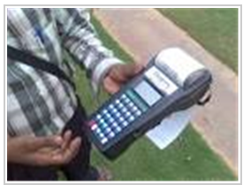
Once reads get captured by any above method, it gets uploaded into the application server for further read validation, Estimation, Exception handling and finally for Billing. Have tried to provide an overview of how this cyclical process works from Route Management to Billing.
Below can be seen the different steps in the Traditional Meter Reading to Billing Process which is monthly process for any Bill/Service Cycle i.e. any particular Meter will be read only once in a month which will be present on any particular Service cycle/Route and Sequence.
Ideally Bill Cycle and Service Cycle are same. Bill cycle defines which day account has to be Billed in System, while Service Cycle defines which date account’s meter read has to be captured. So mostly in any Utility business it would be the same.
Example: ABC Meter’s read get captured on Day6 every month (Say it is having Service Cycle Day6, Route# 14002906 and Sequence 110), so each month on 6th day Meter reader will walk through on route# 14002906 and on sequence# 110th meter read will be captured and ideally same day in nightly batch account would get billed based on captured read.
This process starts with the Route Creation where the meters installed on a given path/route are grouped by Routes and are assigned to a cycle. The reason for grouping is to maximize the meters to be read on a given route. The next step is the Route Scheduling. This involves the scheduling of the reading of the routes for different dates in a month. The next step is the Meter Reading process which is typically manual meter reads. The meter reader walks up to the meters and reads the meters. The next step is the data collection system which takes care of receiving the reads and sending those to the billing system. Typically this is done, by multiple systems. After the collection system sends the reads, the reads are processed and validated by the billing system and the exceptions are reported. The exceptions are analyzed and corrected.
Traditional Meter Reading to Billing Process

Route Management and Scheduling
Above has been illustrated how to capture meter read and bill the account, Now It is very essential to understand the Importance of Bill Cycle, Structured Service Cycle and Route Management for effective and efficient Billing.
In general number of bill cycles is determined by the frequency that you bill your customers. So, for example, if you bill every month, approximately will be having 20 to 25 bill cycles – one for each bill day during the month. If need to bill bimonthly, will be having 40 bill cycles. If need to bill quarterly, will be having 60 bill cycles. Etc.
Now to distribute the complete consumer base equally on day wise need to create Service Routes so that consumers can be allocated across each Service Route to balance the work load among Meter readers and to collect meter readings effectively each route will be having unique Route# so that any further clarification on meter reads can be received via particular Bill Cycle Service Route etc.
Example- XYZ Electricity Supply Company has 3,00,000 consumer base and works Monday to Saturday/ 6days a week to collect the meter reads and Bill the accounts, it means approx. 12,000 meter has to be read every day (25 working days/month i.e. 25 Bill/Service Cycle).
Now it is equally important to create enough no. of Service route to collect 12,000 meter reads every day. So to distribute the 12,000 meters on various routes there must be around 40 Service routes, having each 300 meters to be read and also these 300 meter must be defined in proper sequence on Service Route. Because while downloading the data from Application Server to Hand held device each Meter reads will be getting downloaded in the same sequence as defined on the Service Route, which will be getting used in the same sequence by Meter reader to capture the present meter reads to Bill the account on the spot.
Service CycleService Route Route Sequence (Seq. in which meter reads has to be captured from various houses on that particular route). As shown in below picture.

- Every metered service point references a service cycle, route, and sequence within the route.
- The service cycle controls WHEN the service point’s meter is read.
- A service cycle typically contains many routes. A route is a logical group of service points whose meters can be read by a meter reader on a given day.
- A service point’s sequence defines the order within a route that the service point is read.
- Every service cycle has a service cycle schedule that defines the dates on which the routes within a cycle are read.
- Shortly before the scheduled meter read date, the system creates a download file containing information to be sent to your handheld software. This download file contains information about every register on every meter in every route in the cycle being downloaded except Smart Meters which reads can captured by using MDM etc.
Now have fair Idea on Bill/Service Cycle, Service Routes and Route Sequence, let us try to understand the needs to change the Service Cycle/Route or Route Sequence of an existing account/Premise/House.

Utility may have some business requirement to change the certain group of consumer from one service cycle/route to another service cycle/route or as well need to change the route sequence to increase the Billing efficiency or for better Meter read management or may by adding additional Service Cycle or Service Route want to reduce the load on existing Service Cycle/Route etc. could be the reason when Utility may reshuffle some of the existing accounts to another Service Cycle and Service Route.

Pre-Requisites

Teams involved in Service Cycle, Service Route or Route Sequence Management should have thorough understanding of Utility Service Cycle and route plans and enough Idea in Oracle Customer Care and Billing application.
This document will help to understand the concept of Service Cycle, Service Routes and Route plans/sequence in CC&B by illustrating various scenarios based on Business requirements and will help the users in making changes as required.

Process of Service Cycle and Route change

Let us consider a dummy Account to understand how to change the Service cycle and Service Route if required. Below are the screens, have shown an account having the following service cycle, Service Route and Route Sequence.

Service Cycle: 1L06
Service Route: 14002906
Route Sequence: 110

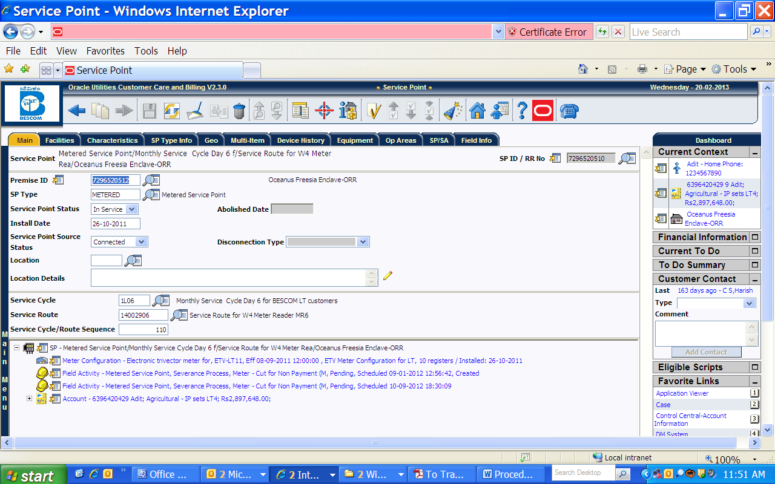

Suppose due to business requirement need to change the Service Cycle from 1L06 to 1L01 and
Service Route from 14006506 to 14006501

Follow the below steps to accomplish the required change.

Go to Main MenuMeter ReadService Route Transfer

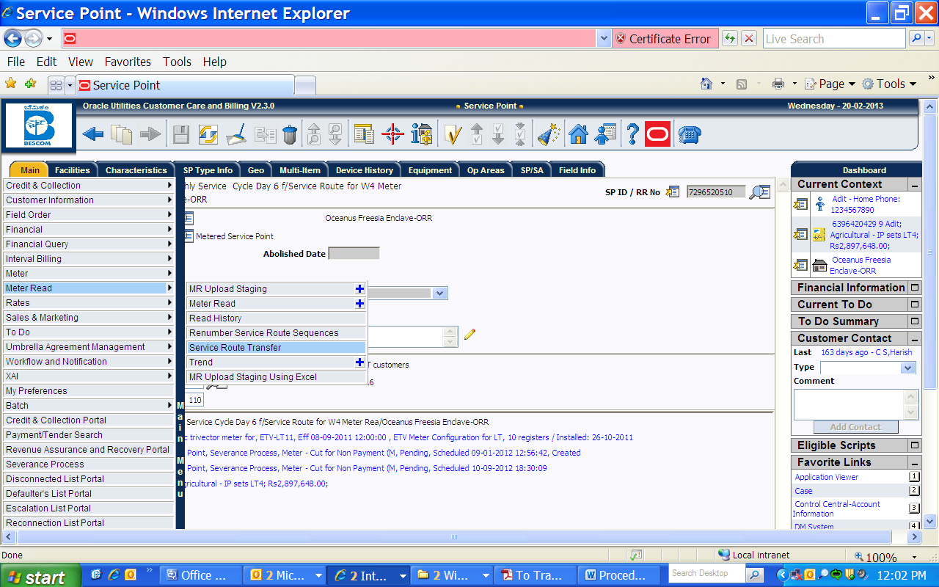

Select the corresponding Service Cycle and the Service route in the Search page

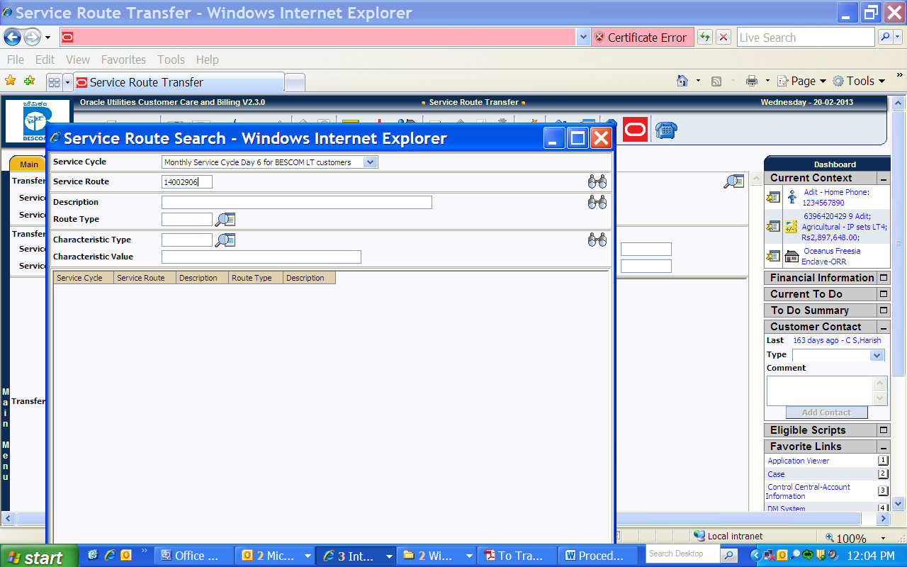

The list below shows our customer in sequence number 110.
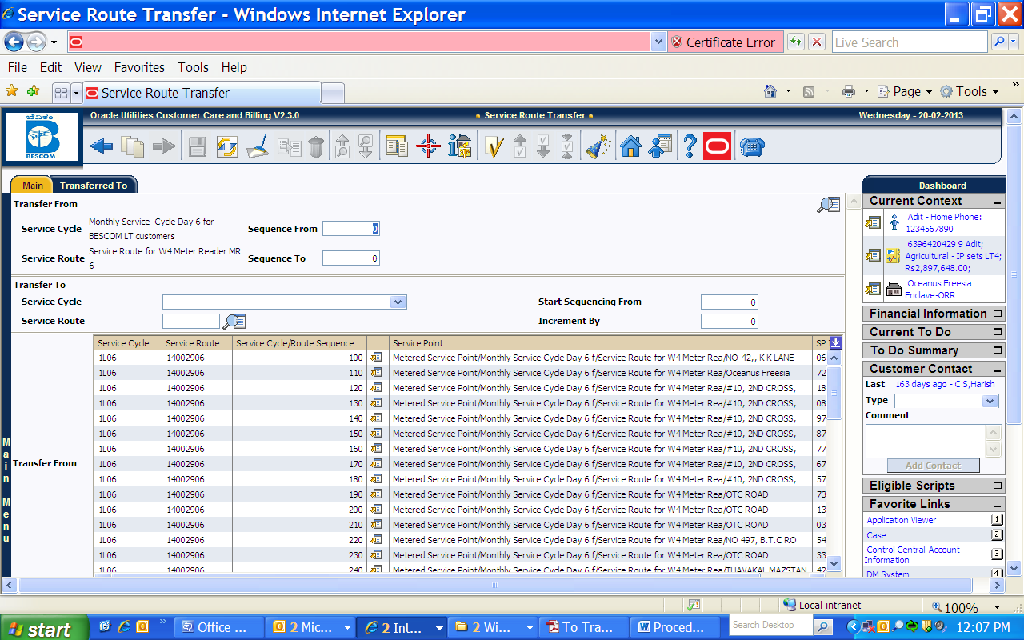

Field Description on Page-
Follow the instructions below to transfer service points from one route to another:
• Use the search button to select the Service Cycle and Service Route that contains the service points to be transferred. Upon return from the search, you are shown all of the service points in the input cycle and route in the Transfer from grid.
• In the Transfer From section at the top of the page, enter the sequence number of the first service point to be transferred in Sequence From. Enter the sequence number of the last service point to be transferred in Sequence To. Say in our example just need to transfer one customer - then in this case FROM and TO both will be same no. as in our example it is 110.
• In the Transfer To area that follows, enter the Service Cycle and Service Route into which the service points are to be transferred. Enter the sequence number to be assigned to the first service point when it is transferred to the new route using Start Sequencing From. Enter the value by which to increment the sequence number of successive service points using Increment by.

Example: For the above account, will try to transfer the Service Cycle/Route/Sequence based on below inputs-

- Service Cycle: Day 6 Day1
- Service Route: 14002906 14002901
- Sequence: 110 to whichever is available sequence no. on new Service Route*.
Before moving it to other Service Route as precautionary step availability confirmation is always good option (as shown in below screen shoot- On new Service Route sequence 110 and 120 is already present so new account can fit in between 110 and 120, say 115 in case need to fit in between) else any time it can be accommodated in last sequence.

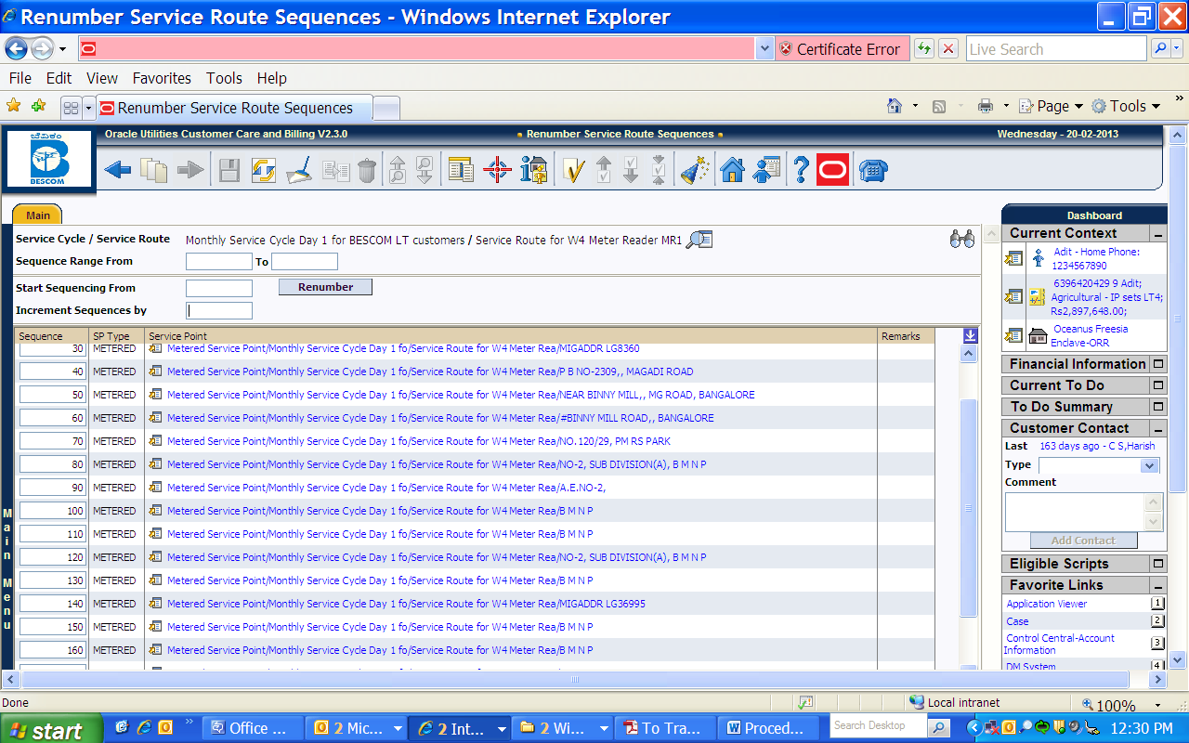

Input has been entered in below screen shot as described above-

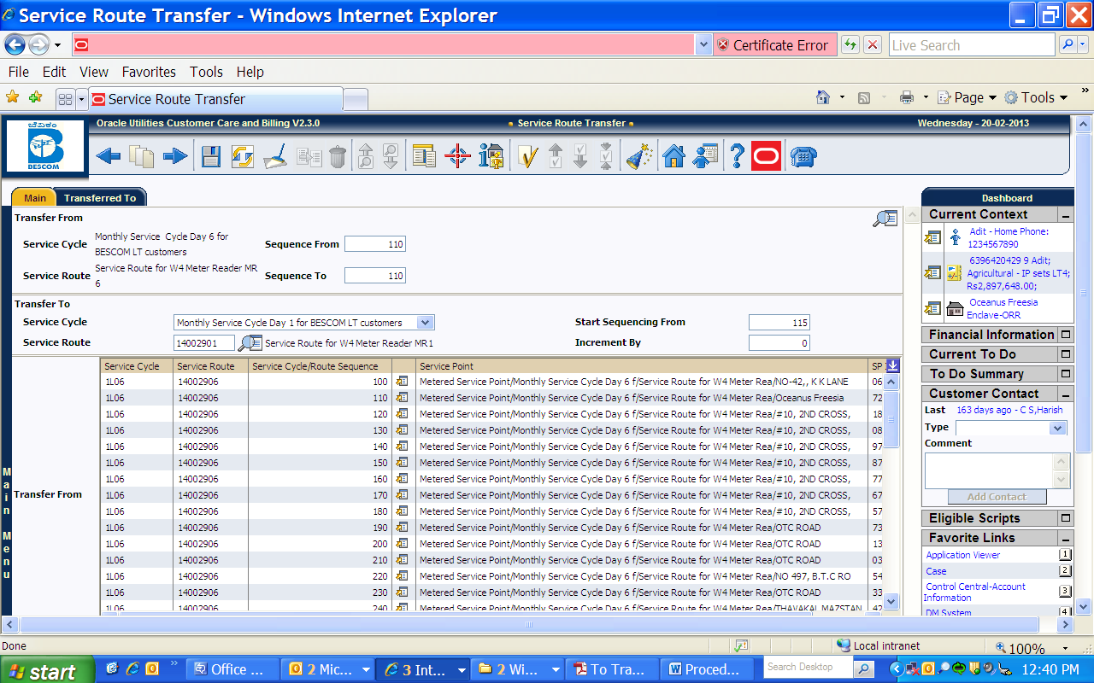

Once done save it and validate account’s Service point and Bill Cycle.
As shown below Service Cycle/Route and Sequence has been changed as expected.
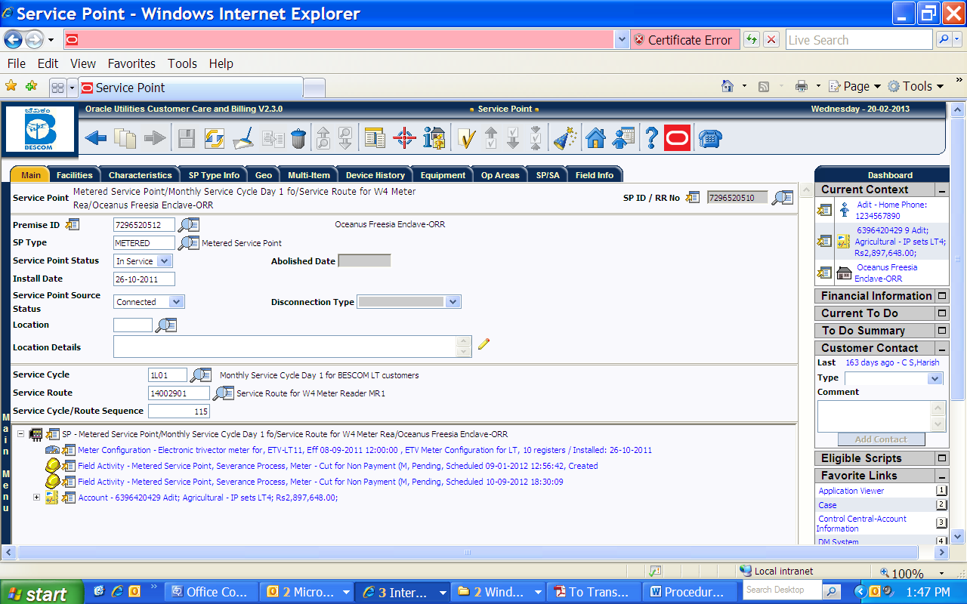

Bill Cycle get updated automatically based on Service Cycle hence Bill cycle also get updated and both are in sync.

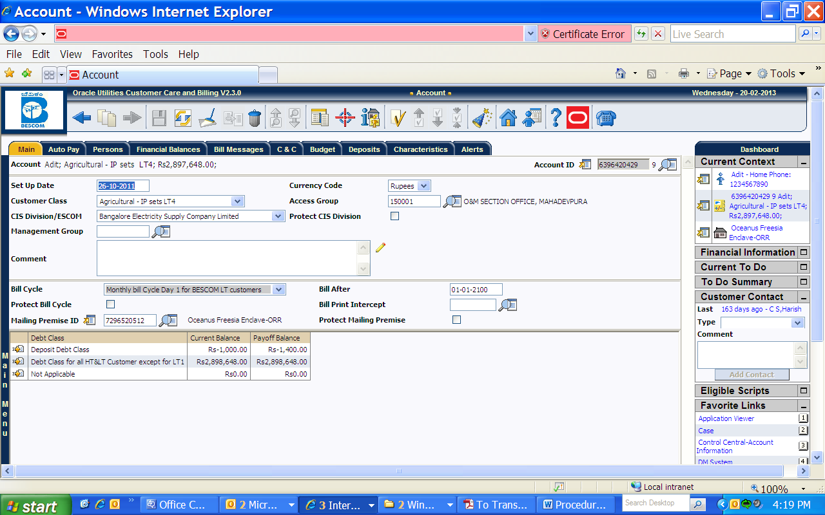

Note: In above example tried to show Service Cycle and route for single account, while this method is very much use full when need to transfer the same for multiple accounts in one go.
While transferring the Service Cycle, Service Route and Sequence- Probably Issue comes with the Sequence availability in new Service Route if need to insert it in between else any time last sequence is always available.

If need to accommodate the sequence in between the existing sequence on new Service Route and there is no gap/space available between the desired sequence then gap/space can be created by Re-Sequencing the route plan as shown below.
This practice is also important because sequence should be unique and cannot be overlapped, hence proper route plan is always important in any utility and over the time may require.

Re sequencing the Route Plan-

Go to Main Menu Meter Read Renumber Service Route Sequence

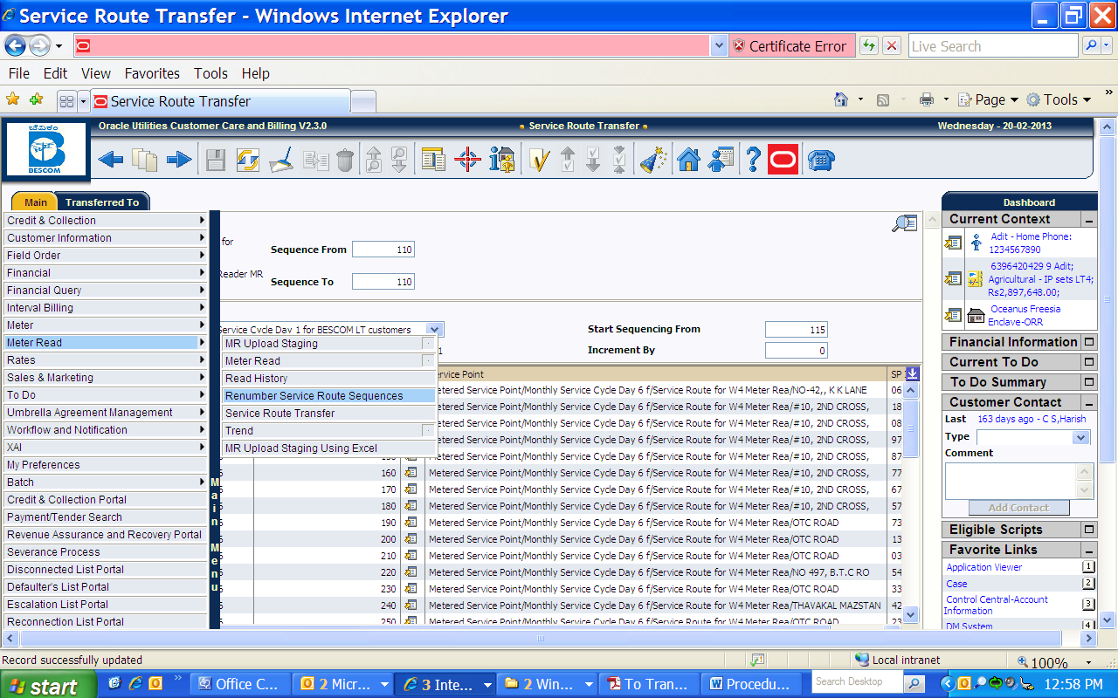

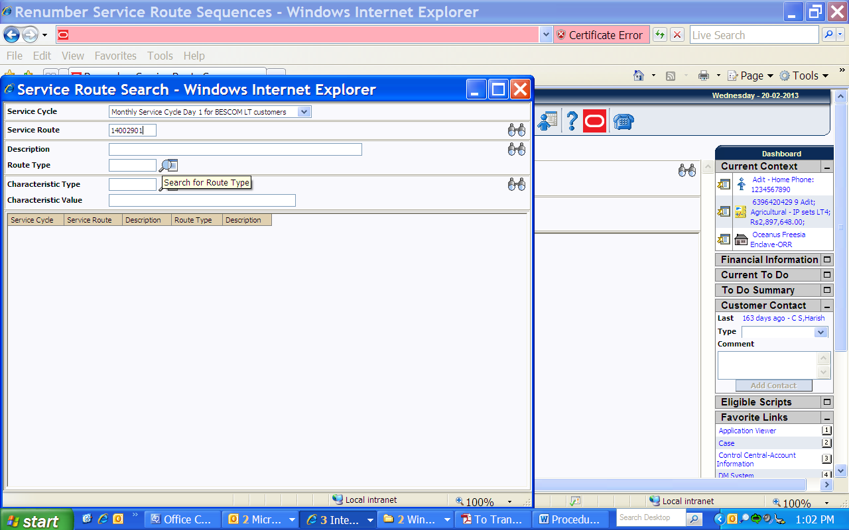

Field Description on Page
Use the search button to select the Service Cycle and Service Route whose service points are to be re sequenced. When the page opens, it will be shown all of the service points in the cycle and route, ordered by current sequence number.
Use the Sequence Range From and To fields to display service points in the grid within a sequence range.
Use the Sequence column in the grid to manually change a service point’s sequence number. You can manually change sequence numbers of up to 150 service points at a time. Click the save button to apply changes. Service points with duplicate sequence numbers are highlighted in the Remarks column.
To re sequence all service points within the route, enter the value from which the system should Start Sequencing From and the amount to Increment Sequences by and then click Renumber. Good values to enter would be 5 and 5 respectively. If you specified values in the Sequence Range From fields, only the service points whose sequences fall within the specified range are renumbered.
Now let us do Re numbering as shown below-
Enter the appropriate values and Click on ‘Renumber’
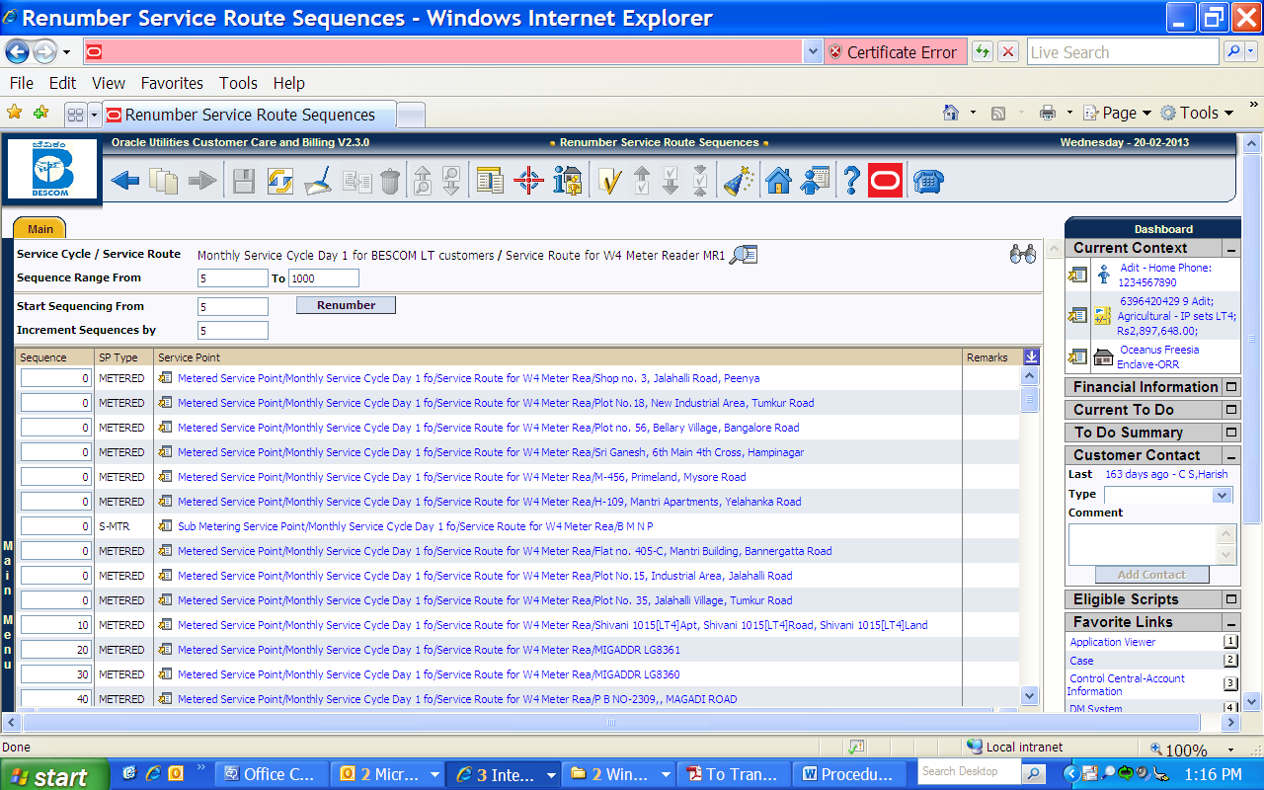
Re sequencing has done as shown below- It starts from 5 and getting incremented by 5.
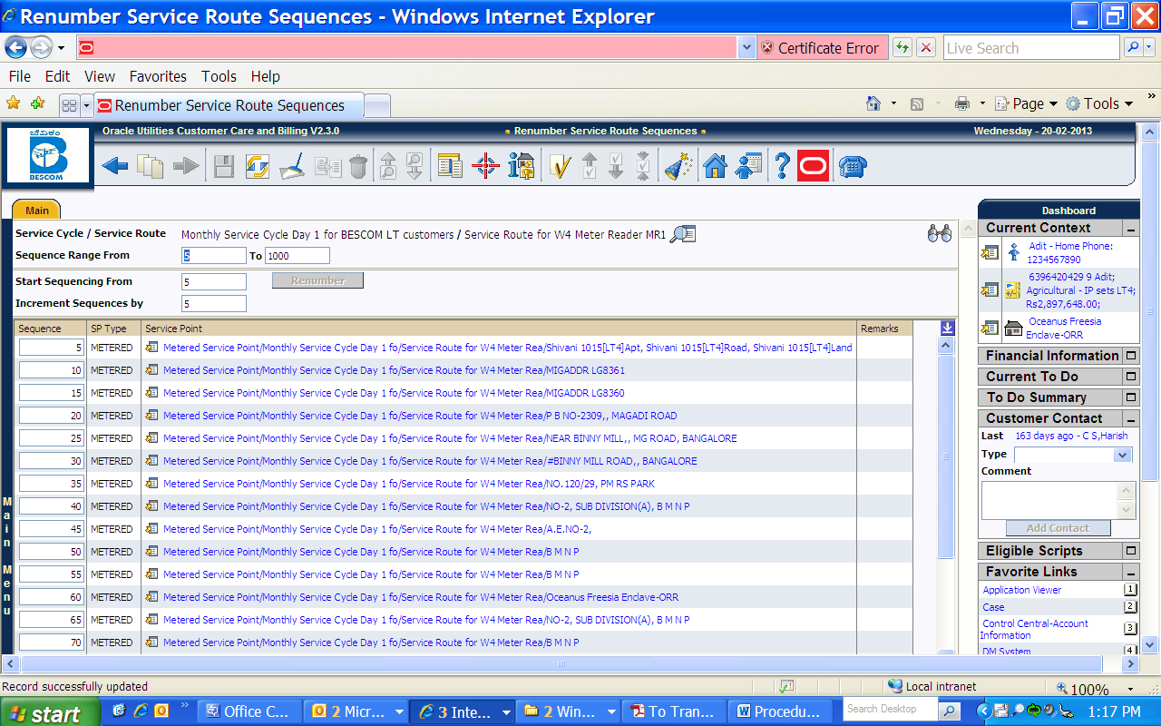

Appendix
- SBM- Spot Billing Machine.
- AMR- Advance Metering Infrastructure.
- RF Based – Radio Frequency based.
- MDM- Meter Data Management.

